MID Server Installation
Process to Install MID Server in ServiceNow
Process: -
- If you have already existing user with mid_server role then you can use that or you can create new user.

- For new User Navigate All > Users > Create New
- User Id: -MyIsntance
- First Name: - My
- Last Name: - Instance
- Password reset: - Checked
- Assign Role: - mid_server
- Generate Password and create new password.
- Now check the created user ID and Password is correct or not.
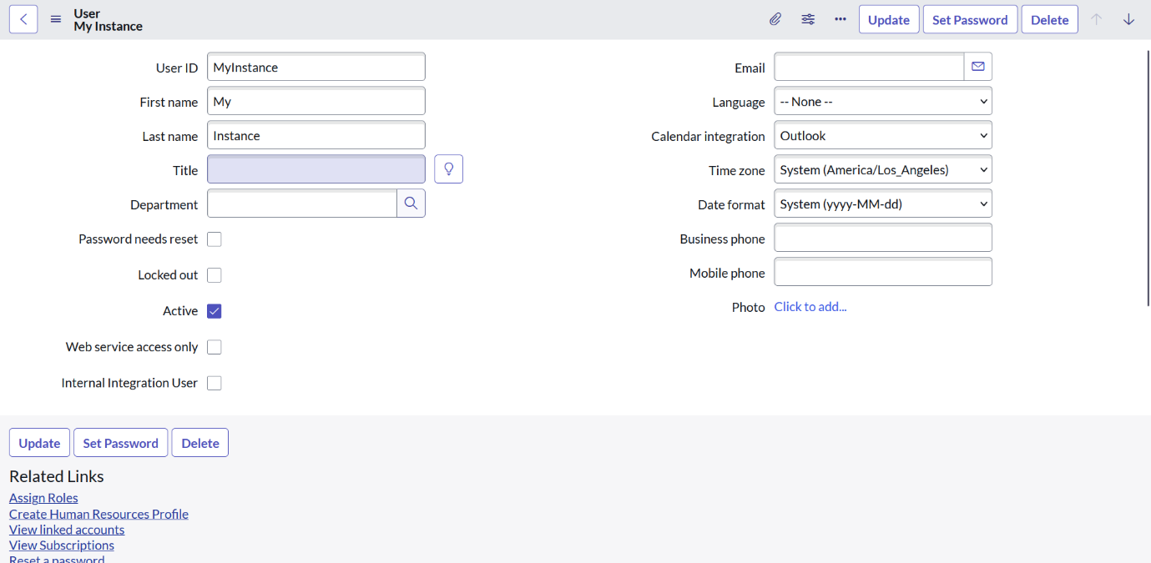

- Now Navigate to All > mid servers > Downloads

- Go to Downloads Zip file of mid server for set up the server.
- Create new folder with any name/use any existing folder and extract the downloaded file there.
- Open Config in notepad and set the Instance name , Username and Password.

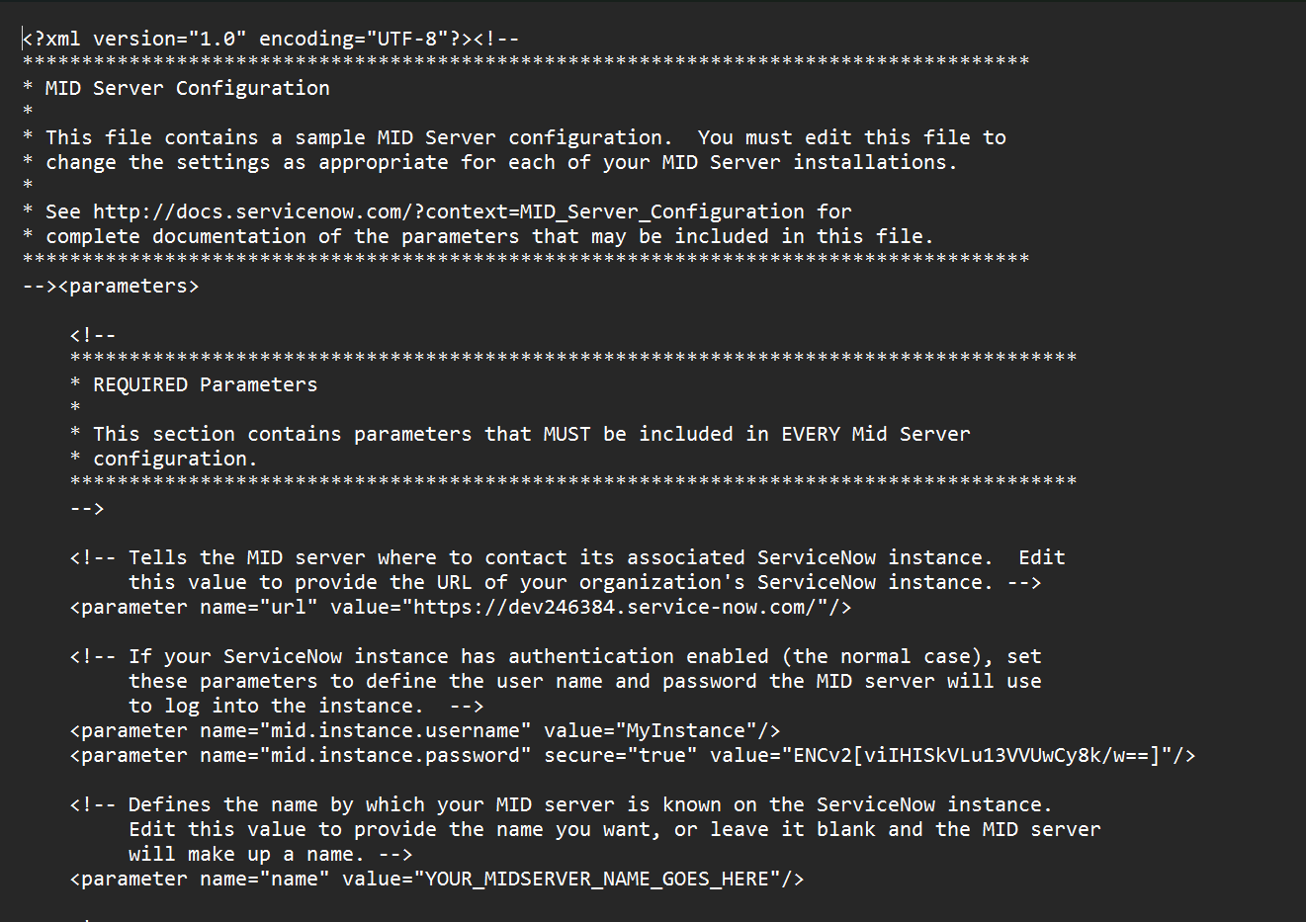

Now, go back on folder and start the Server.
- Now check the server is created or not : -

Navigate All > Mid Server > Servers
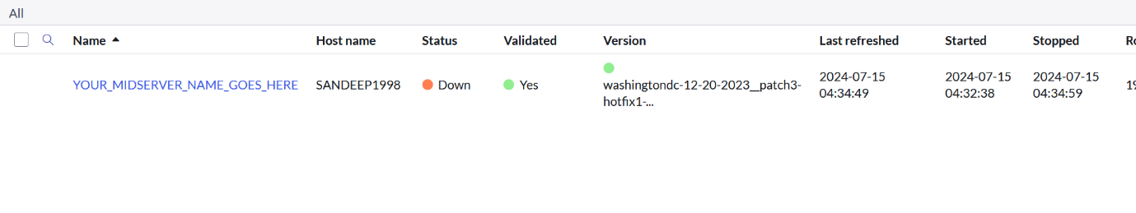
- Now we need to validate this server

- To validate it, open Server and There is an option for validate it. We need to click it and then our server will validate.

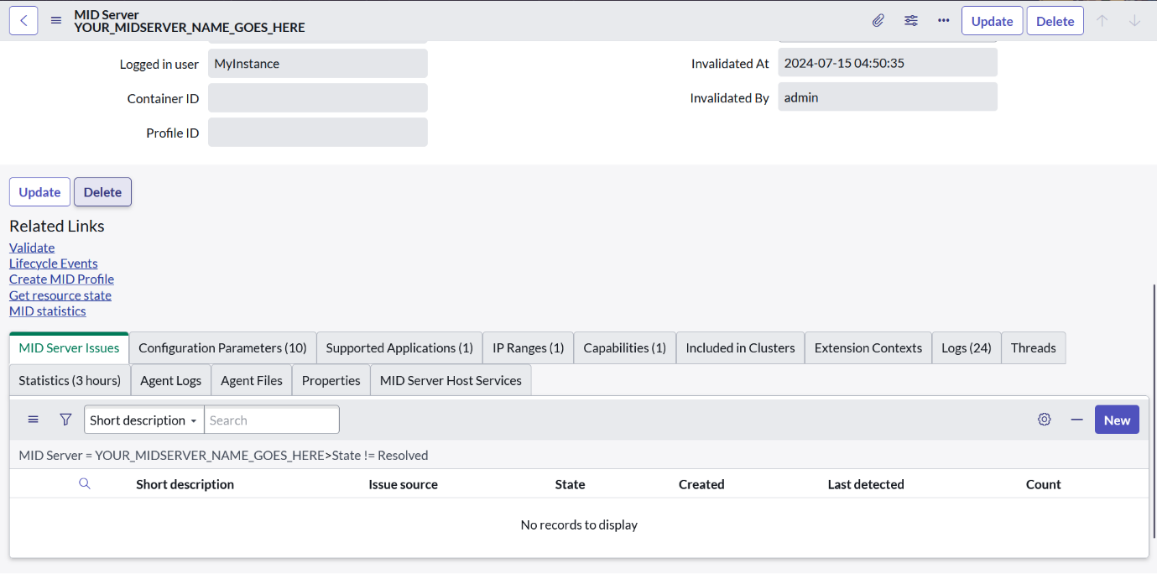

Result: -

